SCREENSHOTS HACKERRANK

1.BFS ALGORITHM

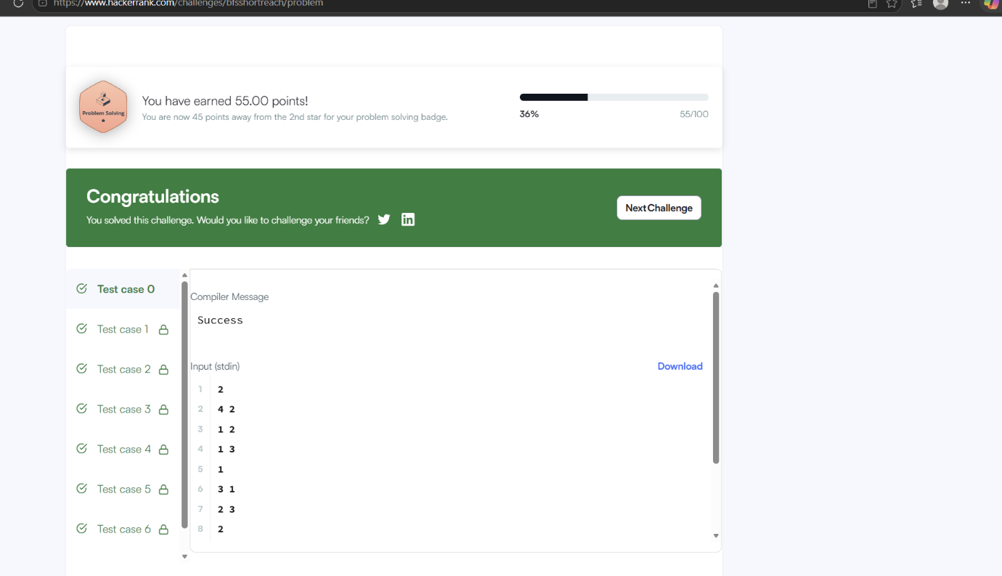

2.PRIM’S ALGORITHM:

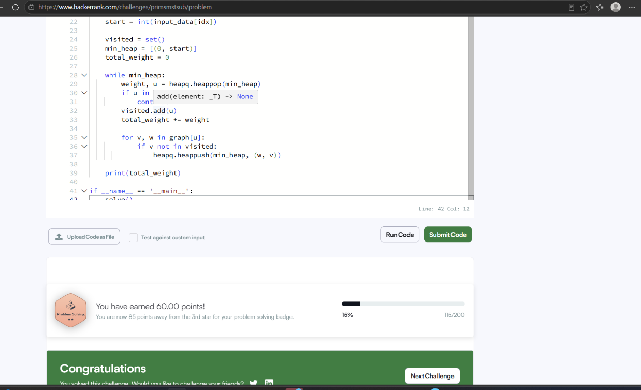
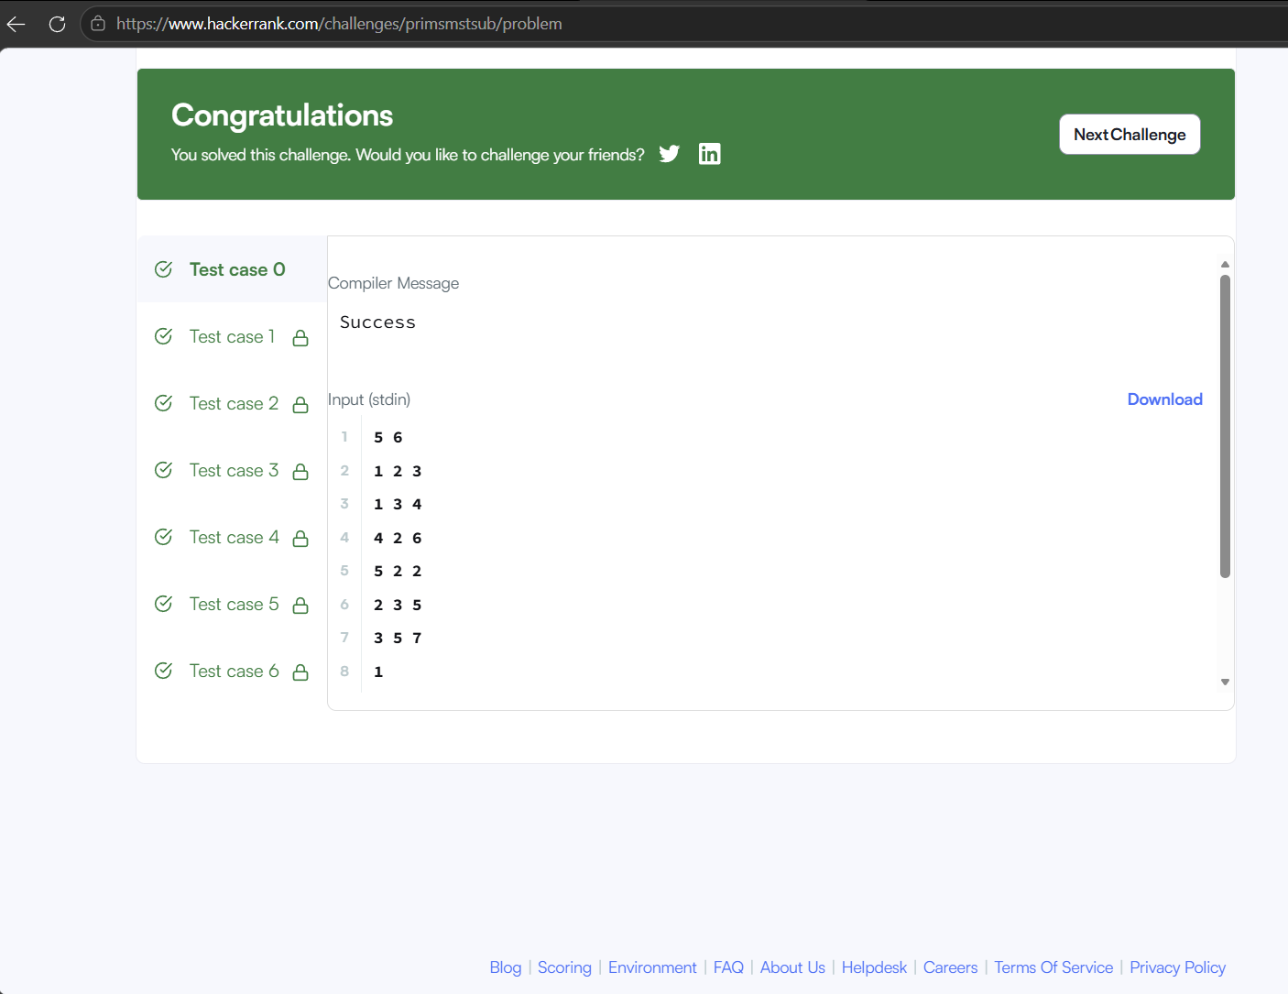

3.DIJKSRA-SHORTEST PATH:
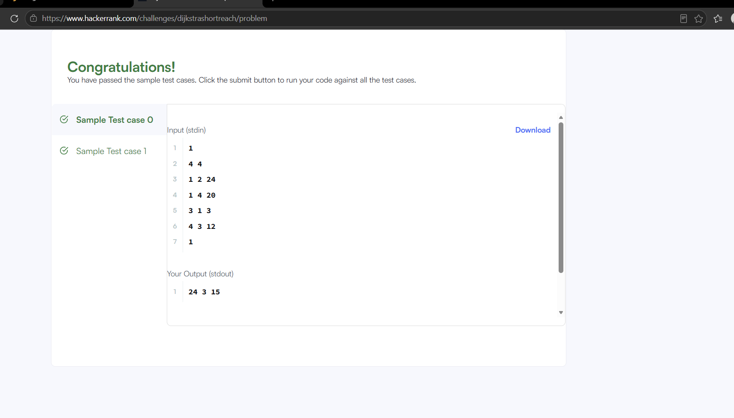

5.KRUSKAL ALGORITHM:
